K L UNIVERSITY
FRESHMAN ENGINEERING DEPARTMENT

A Project Based Lab Report On

ONLINE ORDER PROCESSING AND TRACKING SYSTEM (OOP-TS SUBMITTED BY:
2500031811 M. Hanumanth Reddy
2500031871 Sanku. Sai
2500031935 I. Nischal Sai
2500032062 T. Shanker Sriteja

UNDER THE GUIDANCE OF
Dr. N SREERAM
Associate Professor



KL UNIVERSITY
Green fields, Vaddeswaram – 522 502 Guntur Dt., AP, India.

DEPARTMENT OF BASIC ENGINEERING SCIENCES



CERTIFICATE

This is to certify that the project based laboratory report entitled “ONLINE ORDER PROCESSING AND TRACKING SYSTEM (OOP-TS)” submitted by M.Hanumanth Reddy, Sanku. Sai , I.Nischal Sai, T.Shanker Sriteja bearing Regd.No. 2500031811, 2500031871, 2500031935, 2500032062 to the DEPARTMENT of BASIC ENGINEERING SICENCE-II, K L UNIVERSITY in partial fulfillment of the requirements for the completion of a project based Laboratory in “Python Programming (25SC2007)” course in I B Tech II Semester, is a Bonafide record of the work carried out by them/him/her under my supervision during the academic year 2025 – 2026.

Dr. N SREERAM Dr. D. HARITHA

PROJECT SUPERVISOR HEAD OF THE DEPARTMENT

ACKNOWLEDGEMENTS

It is great pleasure for me to express my gratitude to our honorable President. Sri. Koneru Satyanarayana, for giving the opportunity and platform with facilities in accomplishing the project-based laboratory report.
I/We express sincere gratitude to our Director Dr. A. Jagdeesh for his administration towards our academic growth. I/We express sincere gratitude to our Principal Dr. V. Krishna Reddy for his administration towards our academic growth.
I/We express sincere gratitude to our Coordinator and HOD-BES Dr. D. Haritha for her leadership and constant motivation provided for the successful completion of our academic semester. I/We record it as my/our privilege to deeply thank you for providing us with the efficient faculty and facilities to make our ideas into reality.
I/We express my/our sincere thanks to our project supervisor Dr. N SREERAM for his novel association of ideas, encouragement, appreciation, and intellectual zeal which motivated me/us to venture this project successfully.
Finally, I/We am/are pleased to acknowledge my/our indebtedness to all those who devoted themselves directly or indirectly to making this project a success.

ID NUMBER NAME
2500031811 M. Hanumanth Reddy
2500031871 Sanku. Sai
2500031935 I. Nischal Sai
2500032062 T. Shanker Sriteja

ABSTRACT

The Online Order Processing and Tracking System (OOP_TS) is designed to streamline and automate the process of placing, managing, and tracking customer orders in an efficient and user-friendly manner. This system leverages Object-Oriented Programming (OOP) principles such as encapsulation, inheritance, and polymorphism to ensure modularity, scalability, and maintainability.The application enables users to browse products, place orders, and track their order status in real-time. It also provides administrative functionalities such as managing inventory, updating order status, and handling customer details. The system ensures data accuracy, reduces manual effort, and enhances the overall user experience through automation.By implementing features like order confirmation, status updates (processing, shipped, delivered), and secure data handling, the system improves operational efficiency for businesses while offering transparency and convenience to customers. This project demonstrates how OOP concepts can be effectively applied to develop a robust and scalable real-world application.

INDEX

S.NO | TITLE | PAGE NO
1 | Introduction | 06
2 | Aim of the Project | 07
2.1 | Advantages & Disadvantages | 07
2.2 | Future Implementation | 07
3 | Software & Hardware Details | 08
4 | Algorithm for each module | 09
5 | Flow Chart | 10
6 | Implementation | 11-14
7 | Output/ Screen shots | 15
8 | Conclusion | 16

1.INTRODUCTION

In recent years, the growth of the internet and digital technologies has completely transformed the way businesses operate. Online shopping has become an essential part of everyday life, where customers can purchase products from anywhere at any time. Popular platforms like Amazon, Flipkart, and Meesho provide fast and efficient services by using advanced order processing and tracking systems.

An order processing system is the backbone of any e-commerce platform. It ensures that once a customer places an order, the system records the details, processes the request, updates inventory, and initiates delivery. Along with this, tracking systems allow customers and businesses to monitor the progress of orders from dispatch to final delivery. Without such systems, managing large numbers of orders would be extremely difficult and error-prone.

The Online Order Processing and Tracking System (OOP-TS) is developed as a simplified model of these real-world systems. It helps in understanding how orders are created, managed, and tracked using programming techniques. This project is implemented using Python and follows a structured approach using Object-Oriented Programming (OOP) concepts such as classes, objects, and methods.
The system provides various functionalities including order placement, order status updates, searching orders, and tracking shipments. It also maintains records using file handling techniques, ensuring that data is stored and retrieved efficiently. In addition, the project introduces basic data analysis and visualization to study business performance.

This project is not only useful for learning programming concepts but also gives practical exposure to how real-time systems work in industries. It bridges the gap between theoretical knowledge and real-world applications, making it highly valuable for students and beginners

2. AIM

To design and develop a Python-based system that:
- Manages customer orders efficiently
- Tracks order delivery status
- Stores and retrieves order data
- Provides basic analytics and reports

2.1. ADVANTAGES
- Reduces manual work and errors
- Easy to use and understand
- Provides real-time order tracking
- Efficient data storage using files
- Helps in business analysis
- Demonstrates real-world application of Python

2.2. DISADVANTAGES
• Limited to small-scale usage
• No real-time online payment integration
• Basic user interface (console-based)
• Requires manual input
• Not suitable for large enterprise systems
2.3. FUTURE IMPLEMENTATION
- Add GUI using Tkinter or Web interface
- Integrate online payment systems (UPI, cards)
- Use database (MySQL) instead of JSON
- Add login authentication system

3. SYSTEM REQUIREMENTS

SOFTWARE REQUIREMENTS:
The major software requirements of the project are as follows: Language: Python.
Operating system: Windows 10 or more.
Technical requirements: Monitor, CPU, Keyboard, Mouse, etc...

HARDWARE REQUIREMENTS:
- The hardware requirements that map towards the software are as follows: RAM: 8 GB.
- Processor: i5/i7

4. ALGORITHM
Step-1: Start the program
Step-2: Display menu options
Step-3: Read user choice
Step-4: If choice = Place Order
Input customer details
Calculate total
Store order
Step-5 : If choice = View Orders
Display all orders
Step-6: If choice = Search Order
Input search value
Display matching results
Step-7: If choice = Update Status
Input order ID
Update status
Step-8: Save data to file
Step-9: Exit program

5. FLOWCHART
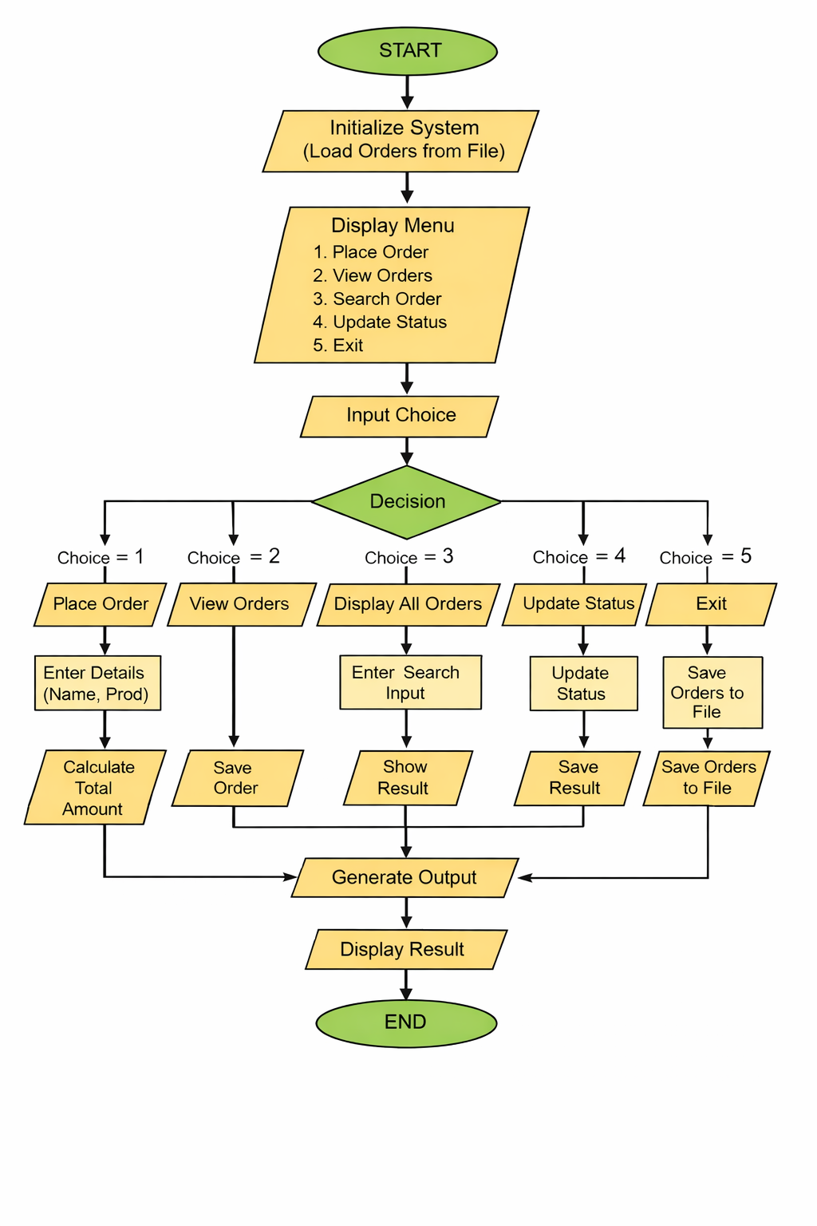

6. IMPLEMENTATION

import json

class Order:
def __init__(self, order_id, customer, product, quantity, price):
self.order_id = order_id
self.customer = customer
self.product = product
self.quantity = quantity
self.price = price
self.status = "Placed"

def calculate_total(self):
return self.quantity * self.price

def update_status(self, new_status):
self.status = new_status

def to_dict(self):
return {
"order_id": self.order_id,
"customer": self.customer,
"product": self.product,
"quantity": self.quantity,
"price": self.price,
"status": self.status
}

def display(self):
print(f"{self.order_id} | {self.customer} | {self.product} | "
f"{self.quantity} | {self.price} | {self.status} | Total: {self.calculate_total()}")

def save_orders(orders):
with open("orders.json", "w") as f:
json.dump([o.to_dict() for o in orders], f, indent=4)

def load_orders():
try:
with open("orders.json", "r") as f:
data = json.load(f)
return [Order(**d) for d in data]
except:
return []

def add_order(orders):
try:
order_id = len(orders) + 1
customer = input("Enter customer name: ")
product = input("Enter product name: ")
quantity = int(input("Enter quantity: "))
price = float(input("Enter price: "))

if quantity <= 0 or price <= 0:
print("Invalid input!")
return

order = Order(order_id, customer, product, quantity, price)
orders.append(order)

print("✅ Order placed successfully!")

except:
print("❌ Error in input!")

def view_orders(orders):
if not orders:
print("No orders found!")
return

print("\nID | Customer | Product | Qty | Price | Status | Total")
print("-" * 60)
for o in orders:
o.display()

def search_order(orders):
name = input("Enter customer name to search: ").lower()
found = False

for o in orders:
if name in o.customer.lower():
o.display()
found = True

if not found:
print("No matching orders found!")

def update_order_status(orders):
try:
oid = int(input("Enter Order ID: "))
for o in orders:
if o.order_id == oid:
print("1. Packed 2. Shipped 3. Delivered 4. Cancelled")
choice = input("Select status: ")

status_dict = {
"1": "Packed",
"2": "Shipped",
"3": "Delivered",
"4": "Cancelled"
}

if choice in status_dict:
o.update_status(status_dict[choice])
print("✅ Status updated!")
else:
print("Invalid choice!")
return

print("Order not found!")

except:
print("Invalid input!")

def main():
orders = load_orders()

while True:
print("\n===== ONLINE ORDER SYSTEM =====")
print("1. Place Order")
print("2. View Orders")
print("3. Search Order")
print("4. Update Status")
print("5. Save & Exit")

choice = input("Enter choice: ")

if choice == "1":
add_order(orders)

elif choice == "2":
view_orders(orders)

elif choice == "3":
search_order(orders)

elif choice == "4":
update_order_status(orders)

elif choice == "5":
save_orders(orders)
print("Data saved. Exiting...")
break

else:
print("Invalid choice!")

if __name__ == "__main__":
main()

7. INPUT & OUTPUT SCREENSHOTS

Screen Shots:

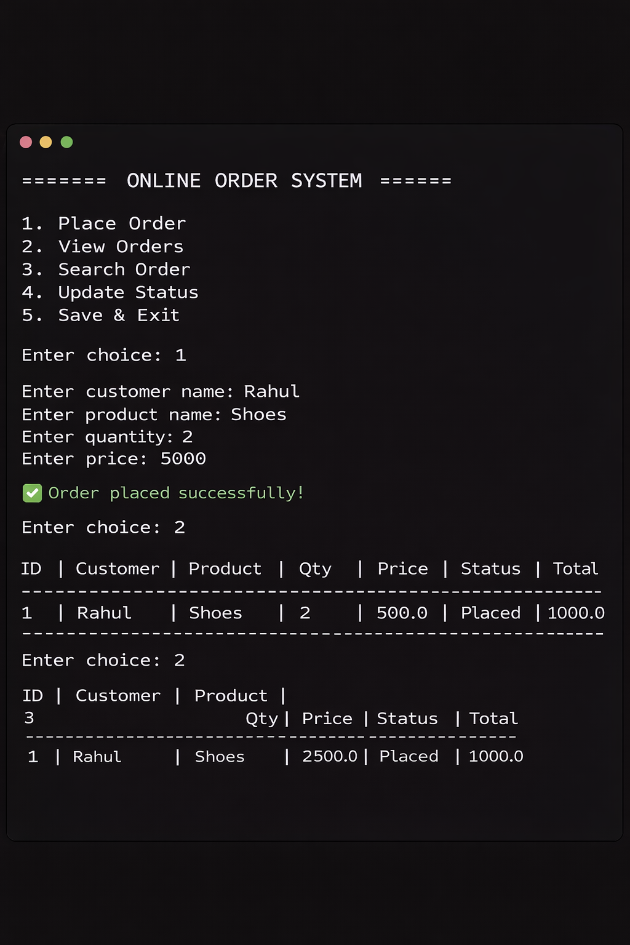

8.CONCLUSION

The Online Order Processing and Tracking System successfully demonstrates how real-world e-commerce systems work. It provides a clear understanding of order management, tracking, and data handling using Python. The project enhances programming skills and helps in applying theoretical concepts to practical applications. It can be further improved and expanded into a full-scale application in the future.

